Automated Test Scripts (Playwright + pytest)

Project: QA Brains Practice E-Commerce Site
URL: https://practice.qabrains.com/ecommerce-site
Framework: Playwright + Python + pytest
Date: November 06, 2026
Author: Netshisumbewa Khangwelo
Github repo:https://github.com/khangwelo12/QA-project-QA-Brains-Practice-E-Commerce-Site-.git

Simulated Environment Assumptions
- Base URL: https://practice.qabrains.com/ecommerce-site
- All locators are example/placeholder values (replace with real ones after inspecting the live site)
- Example locators used in code:
- Login: `id="username"`, `id="password"`, `id="loginBtn"`
- Add to Cart: `css=".add-to-cart-btn"`
- Cart count: `id="cart-count"`
- Search: `id="search-input"`
- Sort: `id="sort-select"`
- Favorites heart: `css=".favorite-icon"`

How to Run the Tests
1. `pip install -r requirements.txt
2. `pytest tests/ -v --headed`
3. `pytest tests/ -v --headed --slowmo=500`
4. For CI/headless: `pytest tests/ -v

Test Coverage (5 Critical Workflows)
1. Login (valid & invalid)
2. Add to Cart
3. Search + Sort
4. Favorites
5. Checkout

Best Practices Followed
- Page Object Model
- Explicit waits via Playwright auto-waiting
- pytest fixtures for setup/teardown
- Clear comments & docstrings
- Screenshot on failure

Automated Test Scripts (Playwright + pytest) Report

Module1
Login (valid & invalid)

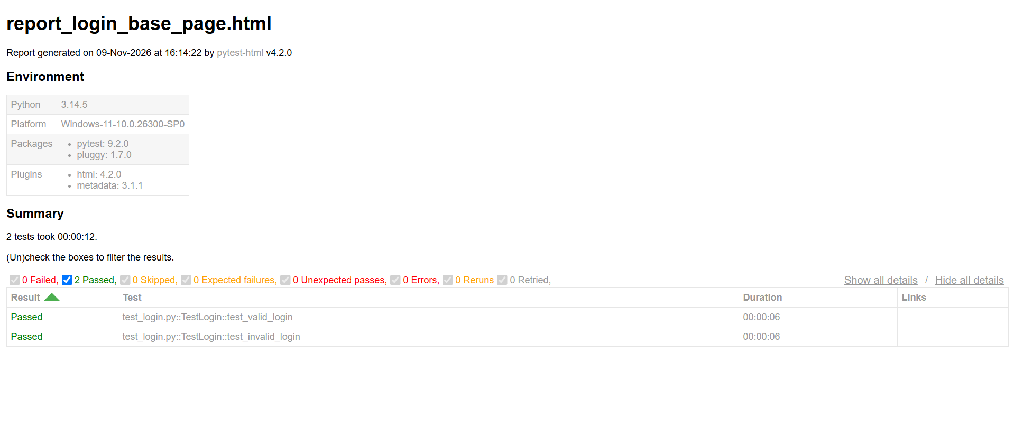
Module 2
Add to Cart
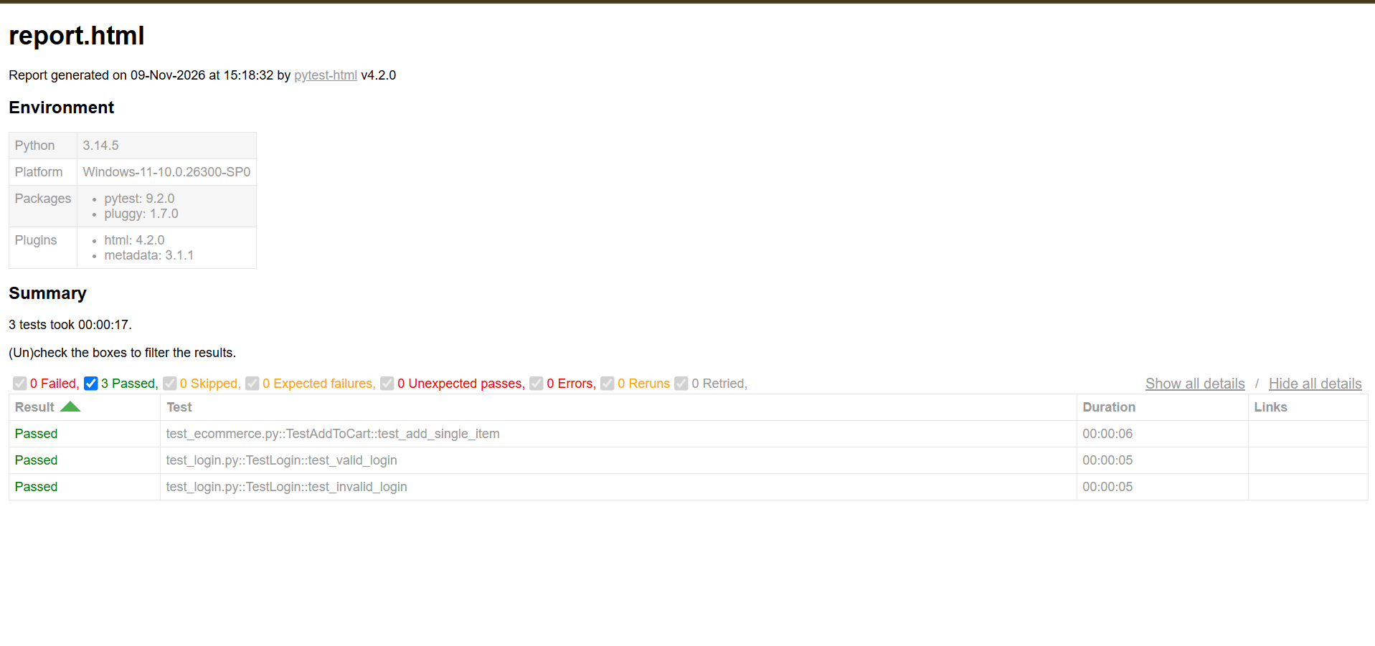
Module 3
Checkout
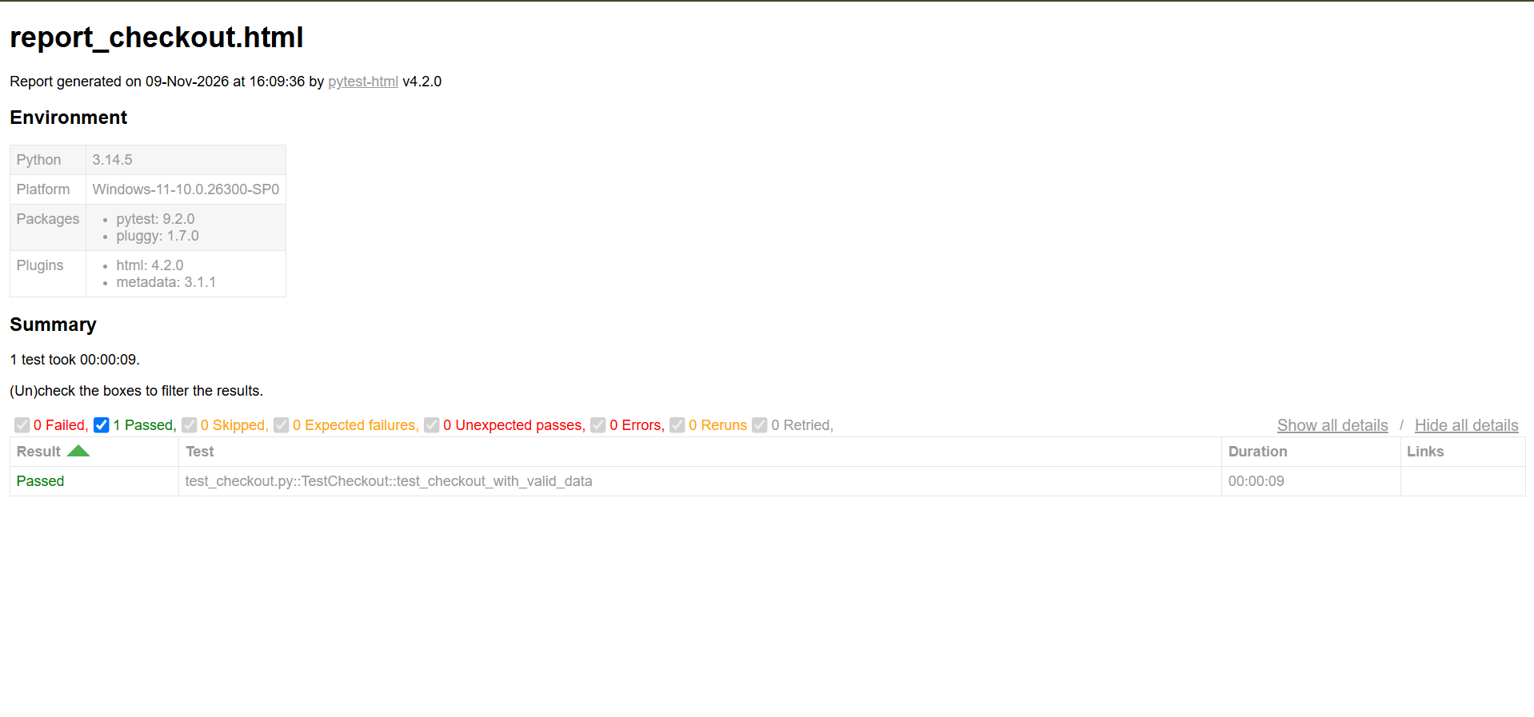
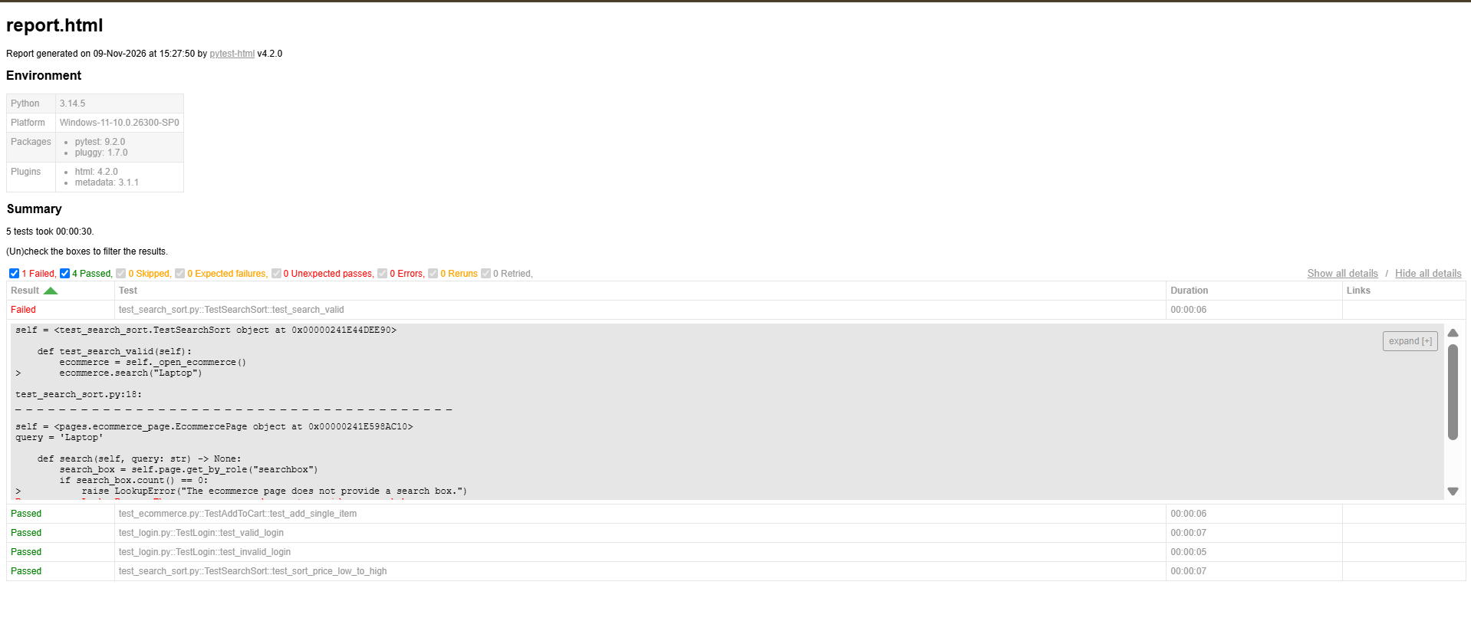

Module 4
Favorites

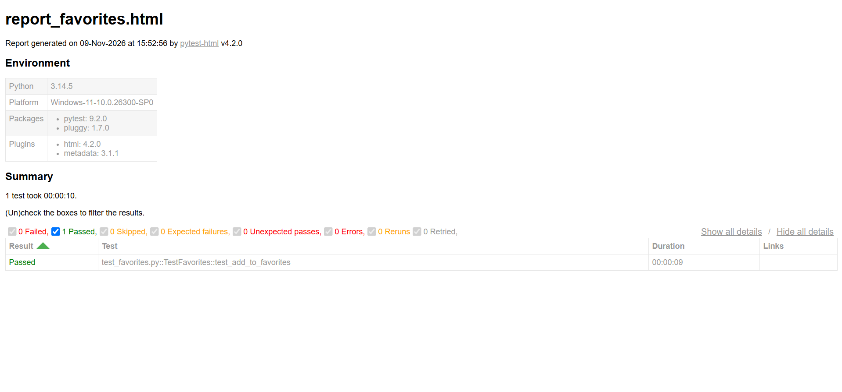
Module 6

